Tip Sheet

Loose Parts

Indicator: 2.1.b: Ensure a variety of appropriate materials, equipment, and resources are available to meet the diverse needs and interests of children.

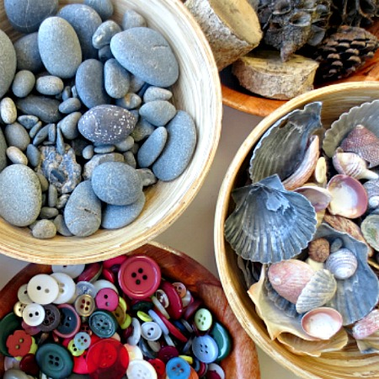
The theory of “loose parts” first proposed by architect Simon Nicholson in the 1970's has begun to influence child-play experts and the people who design play spaces for children in a big way. Nicholson believed that it is the 'loose parts' in our environment that will empower our creativity.

In a play, loose parts are materials that can be moved, carried, combined, redesigned, lined up, and taken apart and put back together in multiple ways. They are materials with no specific set of directions that can be used alone or combined with other materials.
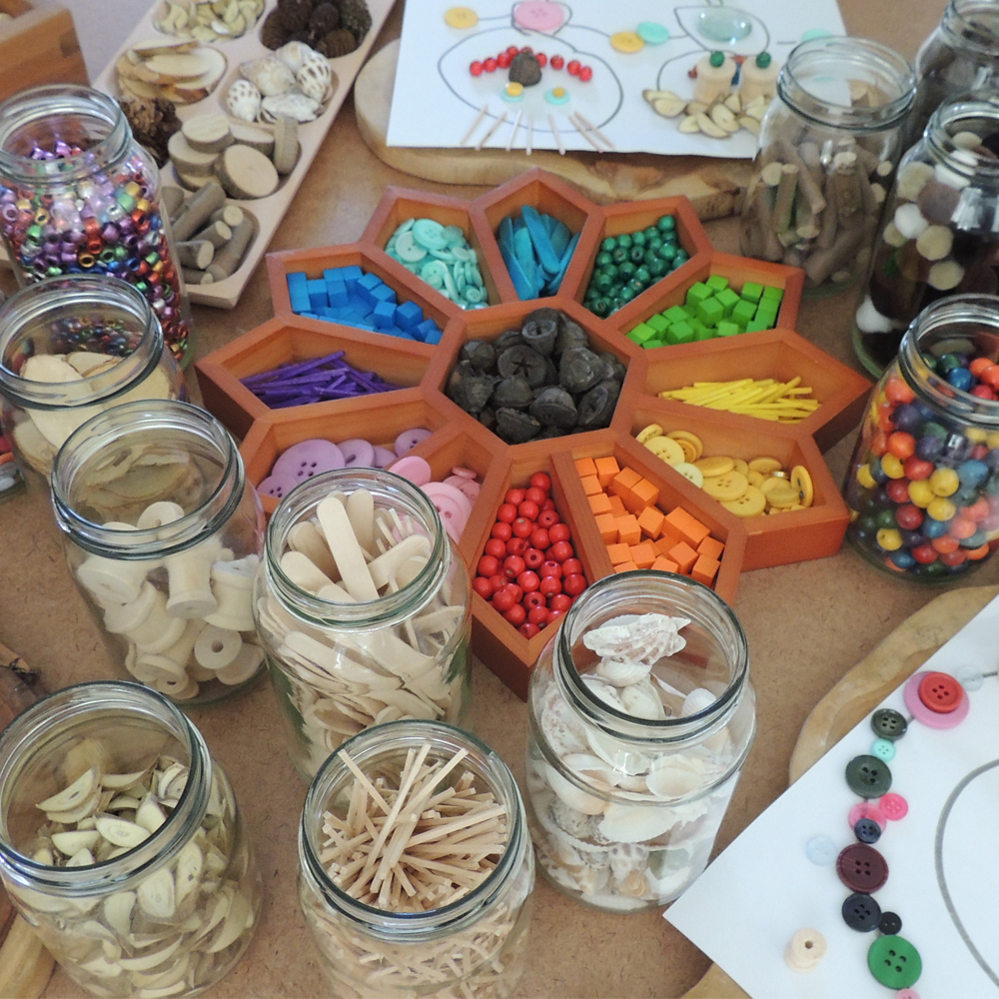
Loose parts can be natural or synthetic. In a preschool outdoor environment we can provide an array of loose parts for use in play such as stones, stumps, sand, gravel, fabric, twigs, wood, pallets, balls, buckets, baskets, crates, boxes, logs, stones, flowers, rope, tires, balls, shells and seedpods. Having "loose parts" available in a play space allows children to use these materials as they choose. Often you will find that children would rather play with materials that they can use and adapt as they please, rather than expensive pieces of play equipment.

Loose Parts should –
• Have no defined use and playworkers must support the children when they decide to change the shape or use of them.
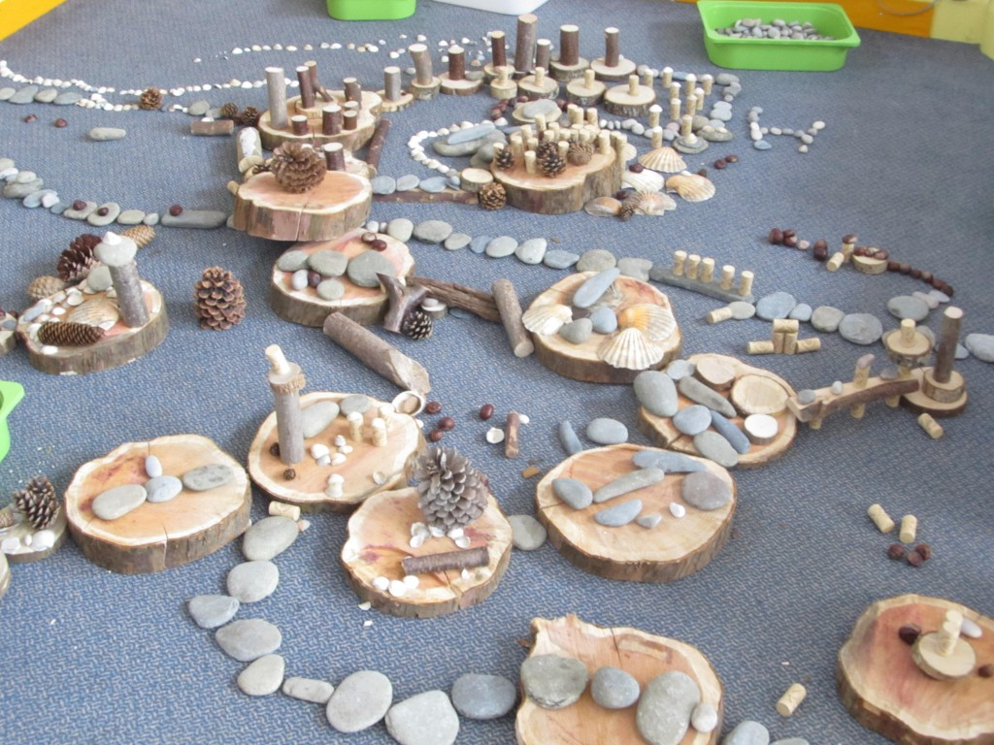
• Be accessible physically and stored where they can be reached by children without having to ask the playworkers. The children should know that they can use them whenever and however they wish.
• Be regularly replenished changed and added

http://www.readingplay.co.uk/GetAsset.aspx?id=fAAyADUAMgB8AHwARgBhAGwAcwBlAHwAfAA4AHwA0
https://www.google.com/search?q=what+are+loose+parts&rlz=1C1CHBD_enCA815CA815&source=lnms&tbm=isch&sa=X&ved=0ahUKEwi3xb79zaPjAhUEsZ4KHTSIBPIQ_AUIECgB&biw=1242&bih=597#imgrc=C3IxmBaN5nbLEM:
https://www.google.com/search?q=what+are+loose+parts&rlz=1C1CHBD_enCA815CA815&source=lnms&tbm=isch&sa=X&ved=0ahUKEwi3xb79zaPjAhUEsZ4KHTSIBPIQ_AUIECgB&biw=1242&bih=597#imgrc=ESqeZ9MKTogTzM:

